Eyeconic - Glasses Shop Management System

Use-Case Specification: Add Glasses

Version 1.0

Revision History

|  |  |  |  |
| --- | --- | --- | --- |
| **Date** | **Version** | **Description** | **Author** |
| 07/11/2019 | 1.0 | Start creating use case | Đỗ Nguyễn Hoàng Ân |
|  |  |  |  |
|  |  |  |  |
|  |  |  |  |

Table of Contents

1. Add Glasses 4

1.1 Brief Description 4

2. Flow of Events 4

2.1 Basic Flow 4

2.2 Exception 4

2.2.1 Add glasses 4

2.2.2 Fill in the glasses information 5

3. Special Requirements 5

4. Preconditions 5

4.1 Admin must be logged in 5

5. Postconditions 5

6. Extension Points 5

Use-Case Specification: Add Glasses

# Add Glasses

## Brief Description

This use case defines the step of removing existing glasses from the database.

Glasses are removed by the admin.

# Flow of Events

## Basic Flow

The system administration clicks a button to add a new item. The administrator fills in the information of the new glasses. The system displays the new glasses and logs the change.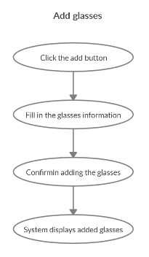

***Basic flow of Adding Glasses***

Step 1: Click the add buttons

The modal view shows up

Step 2: Fill in the glasses information, name, type, …

Step 3: Confirming adding the glasses by clicking the “Save” button.

Step 4: Successful added glasses is added to the screen.

## Exception

### Add glasses

The add button cannot be clicked or isn’t appeared on the screen

### Fill in the glasses information

Invalid information.

Must fill out all the information in the form.

2.2.3 Confirming adding the glasses

The “Save” button is clicked but the new glasses are not added to the database.

This new glasses are existed in the database.

2.2.4 System displays added glasses

The added glasses is not display correctly

# Special Requirements

No Special Requirements

# Preconditions

* User must already login as the administrator of the website
* The added glasses had not existed in the database before.

# Postconditions

Glasses are created, shown on the screen can be purchased by customers.

# Extension Points

Administrator checks the website and the system to ensure that the glasses are added to the database and displayed on the screen.